**DBMS Practical 8**

**Team member: Terris Tan**

**Lee Bohui**

**Stace Chua**

**Table Name:** Staff

**Table Description:** This table stores staff details.

|  |  |  |  |  |
| --- | --- | --- | --- | --- |
| **Column Name** | **Column Description** | **Data Type** | **Allow Null?** | **Integrity Constraint** |
| StaffId | Staff’s NRIC | Varchar(10) |  | Primary Key |
| StaffName | Staff Name | Varchar(50) |  |  |
| StaffGender | Staff’s gender | Char(1) | null | Check constraint: (‘M’,’F’) |
| Position | Staff position | Varchar(20) | null |  |
| StaffLoginId | Staff account login ID | Varchar(10) |  |  |
| StaffPassword | Staff account password | Varchar(10) |  |  |
| DeptCode | Department Code | Varchar(10) |  | Foreign Key |

**Table Name:** Department

**Table Description:** This table stores the department’s details.

|  |  |  |  |  |
| --- | --- | --- | --- | --- |
| **Column Name** | **Column Description** | **Data Type** | **Allow Null?** | **Integrity Constraint** |
| DeptCode | Department Code | Varchar(10) |  | Primary Key |
| DeptName | Department Name | Varchar(40) |  |  |

**Table Name:** Customer

**Table Description:** This table stores customer details

|  |  |  |  |  |
| --- | --- | --- | --- | --- |
| **Column Name** | **Column Description** | **Data Type** | **Allow Null?** | **Integrity Constraint** |
| CustLoginID | Customer’s account ID | Varchar(10) |  | Primary Key |
| CustName | Customer Name | Varchar(50) |  |  |
| CustGender | Customer’s gender | Char(1) | null | Check constraint: (‘M’,’F’) |
| DOB | Customer’s Date of Birth | Date |  |  |
| Address | Customer’s address | Varchar(100) |  |  |
| TelNo | Customer’s contact number | Varchar(8) | null |  |
| Email | Customer’s email | Varchar(40) |  |  |
| CustPassword | Customer account password | Varchar(10) |  |  |

**Table Name:** ShoppingCart

**Table Description:** This table stores customer’s cart ID

|  |  |  |  |  |
| --- | --- | --- | --- | --- |
| **Column Name** | **Column Description** | **Data Type** | **Allow Null?** | **Integrity Constraint** |
| CartId | ID of cart | Varchar(10) |  | Primary Key |
| CustLoginID | Customer’s account ID | Varchar(10) |  | Foreign Key |

**Table Name:** CartList

**Table Description:** This table stores a customer’s cart details

|  |  |  |  |  |
| --- | --- | --- | --- | --- |
| **Column Name** | **Column Description** | **Data Type** | **Allow Null?** | **Integrity Constraint** |
| CartId | ID of cart | Varchar(10) |  | Primary Key (Composite) & Foreign Key |
| ProdCode | Product’s Code | Varchar(10) |  | Primary Key (Composite) & Foreign Key |
| Qty | Quantity of product ordered | int |  |  |

**Table Name:** Product

**Table Description:** This table is to store full information of the products.

|  |  |  |  |  |
| --- | --- | --- | --- | --- |
| **Column Name** | **Column Description** | **Data Type** | **Allow null?** | **Integrity Constraint** |
| ProdCode | Product’s Code | Varchar(10) |  | Primary Key |
| ProdName | Product’s Name | Varchar(20) |  |  |
| Brand | Product’s brand | Varchar(20) |  |  |
| Model | Product’s model | Varchar(20) | null |  |
| ProdDesc | Product’s description | Varchar(200) |  |  |
| UnitPrice | Product’s unit price | Decimal(20 , 2) |  |  |
| QuantityInStock | Product’s quantity in stocks | int |  |  |
| ProdStatus | Product’s status | Varchar(10) |  |  |
| ReplenishLevel | Product’s replenish level | Varchar(10) |  |  |
| ProdTypeCode | Product’s type Code | Varchar(10) |  | Foreign Key |

**Table Name**: ProductType

**Table Description**: This table is to store vague information of the products.

|  |  |  |  |  |
| --- | --- | --- | --- | --- |
| **Column Name** | **Column Description** | **Data Type** | **Allow null?** | **Integrity Constraint** |
| ProdTypeCode | Product’s Type Code | Varchar(10) |  | Primary key |
| ProdTypeName | Products’ Type Name | Varchar(20) |  |  |

**Table Name**: OrderForm

**Table Description**: This table order’s details.

|  |  |  |  |  |
| --- | --- | --- | --- | --- |
| **Column Name** | **Column Description** | **Data Type** | **Allow Null?** | **Integrity Constraint** |
| OrderNo | Order number | Int |  | Primary Key |
| OrderDate | Date of order | Date |  |  |
| TotalAmt | Total sum of items | Decimal(8, 2) |  |  |
| OrderStatus | Status of order | Varchar(15) |  |  |
| DeliveryAddr | Delivery/ Drop-off address | Varchar(100) |  |  |
| BillingAddress | Billing address | Varchar(100) |  |  |
| PaymentType | Payment type | Varchar(25) |  |  |
| CRCardNo | Credit card number | Varchar(30) |  |  |
| PaymentDate | Date of payment | Date |  |  |
| CustLoginID | Customer’s login ID | VarChar(10) |  | Foreign Key |
| ProcessingStaffID | Staff’s id | Varchar(10) |  | Foreign Key |

**Table Name**: OrderItem

**Table Description**: This table order item’s details.

|  |  |  |  |  |
| --- | --- | --- | --- | --- |
| **Column Name** | **Column Description** | **Data Type** | **Allow Null?** | **Integrity Constraint** |
| OrderNo | Order number | Int |  | Foreign Key and Composite Primary Key (OrderNo, ProdCode) |
| ProdCode | Product code | Varchar(10) |  | Foreign Key and Composite Primary Key (OrderNo, ProdCode) |
| Quantity | Quantity of product | Int |  |  |
| PurchasePrice | Total price of products | Decimal(8, 2) |  |  |

Staff

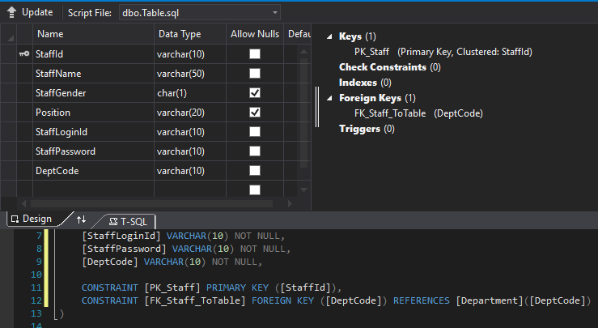

Department

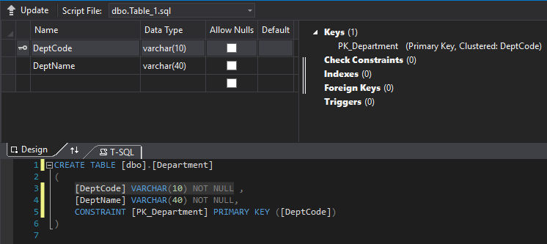

Customer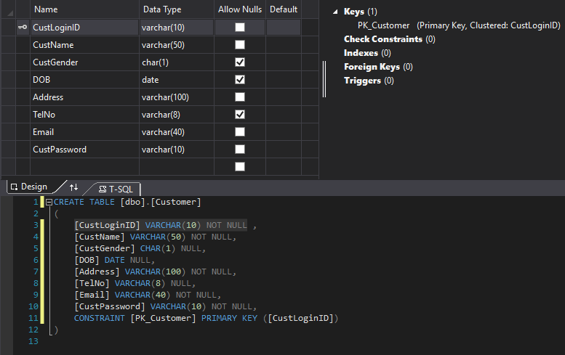

ShoppingCart

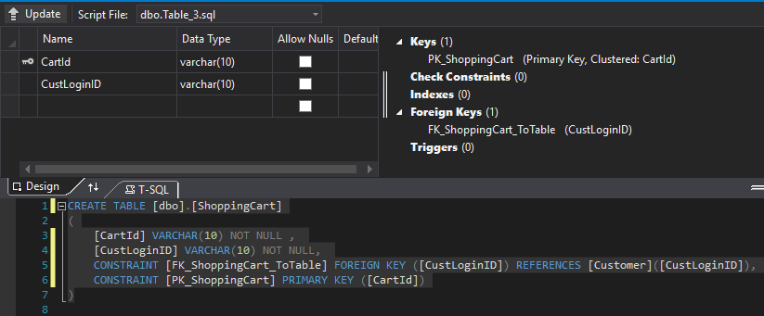

CartList

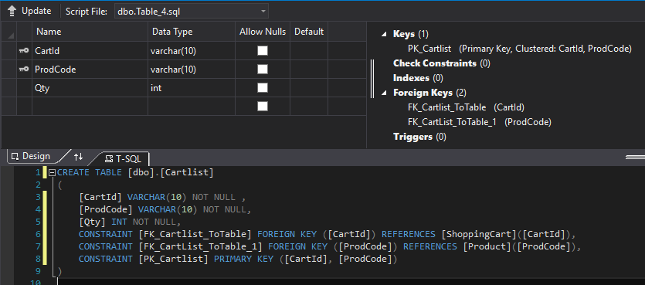

Product

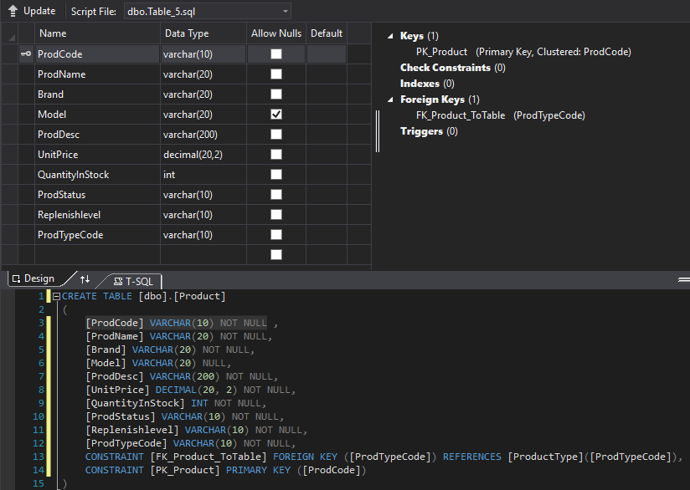

ProductType

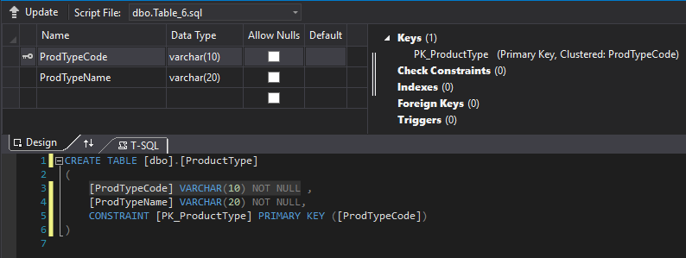

OrderForm

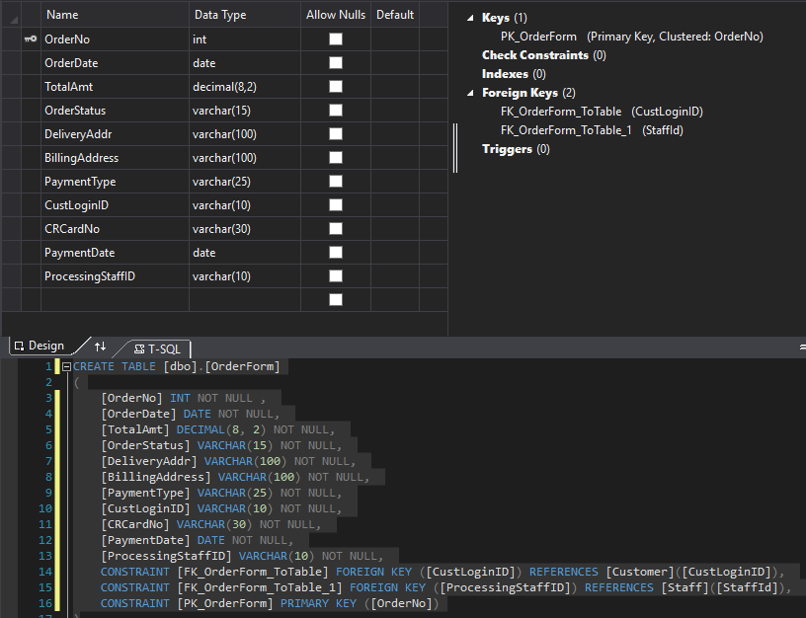

OrderItem